

Wholesaler Cashier APP on C++

Group 1

Names : David Julian Ernestine (2120010033)

Muhammad Rafi Aulia (2120010095)

Isaac Gideon Simamora (2120010068)

Class : 2 ISA 2

CEP CCIT

FAKULTAS TEKNIK UNIVERSITAS INDONESIA

2022

**Developed by**

1. **David Julian Ernestine** (2120010033)
2. **Muhammad Rafi Aulia** (2120010095)
3. **Isaac Gideon Simamora** (2120010068)



**PROJECT ON**

***WHOLESALER CASIR APPLICATION***

***O,***

Batch Code : 2 ISA 2

Start Date : April 15 th, 2022   
End Date : April 21 th, 2022  
Name of Faculty : M. Idham Khalif, S.Kom

Names of Developer :

1. David Julian Ernestine
2. Muhammad Rafi Aulia
3. Isaac Gideon Simamora

Date of Submission: April 21 th, 2022

**WHOLESALER CASHIER APPLICATION**

**CERTIFICATE**

This is to certify that this report titled “ Wholesaler Cashier App” embodies the original work done by David Julian Ernestine , Muhammad Rafi Aulia and Isaac Gideon Simamora . Project in partial fulfillment of their course requirement at NIIT.

Coordinator:

M. Idham Khalif, S.Kom



Praise God Almighty, for the presence of plenty of mercy and his grace, so that the writer can complete this project, both in the form of paper and in the form of presentations on time. Thank you especially to the faculty, Mr. M. Idham Khalif,S.Kom and other faculty who always help and guide the writers to complete this project paper. Thank you to the fellow students who have supported us, and also thank you for being a partner in this education at CCIT-FTUI.

The project paper entitled “Wholesaler Cashier App” which the authors propose as project 2022 task requirements.

Hope the author, hopefully, this paper can be useful for the reader, so that it can add knowledge and insight. The author realizes that this paper is not perfect. Therefore, the authors expect all constructive suggestions and criticisms from the reader to improve this paper.

Finally, hopefully, this paper can provide many benefits for the readers.

Jakarta, April, 21th 2022

**ACKNOWLEDGEMENT**

System Summary:

Wholesalers are intermediaries between producers and retailers in the market. Wholesalers also arrange separate items for payments served by employees.

In carrying out our shop activities. Recent transactions in data collection and storage allow grocery stores to collect various data (purchase data, customer data, transaction data, and so on). This amount of data always increases every year, causing a data explosion. The data collected by wholesalers can of course be used for various purposes, for example a wholesaler can use sales data to determine retail purchasing patterns.

In the example above, the data collected is very large so it would be very difficult to analyze it manually, so We need a way that can automatically analyze the data and then form conclusions for further examination.

In this project, our group creates an implementation in a applicaton cashier wholesaler. In the form of C++ code Input and Output.

**SYSTEM ANALYSIS**

**FLOWCHART**

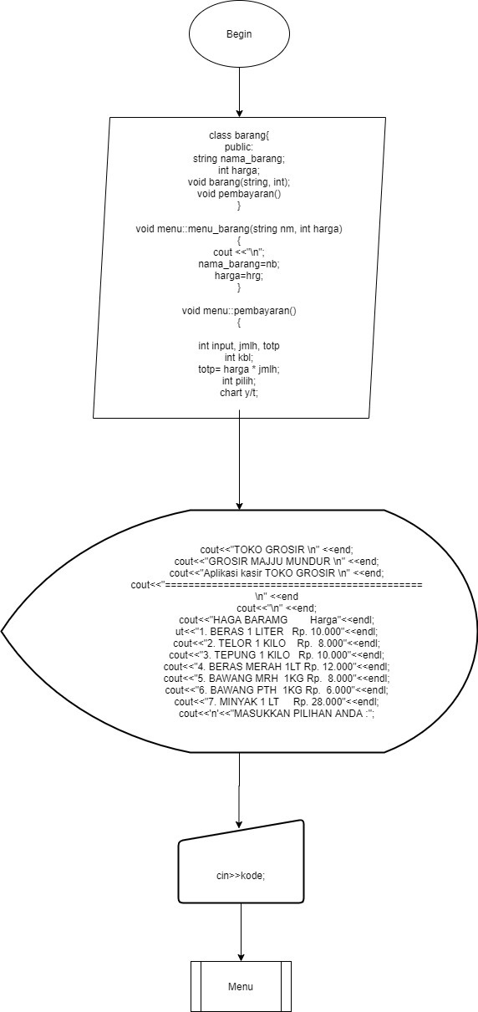

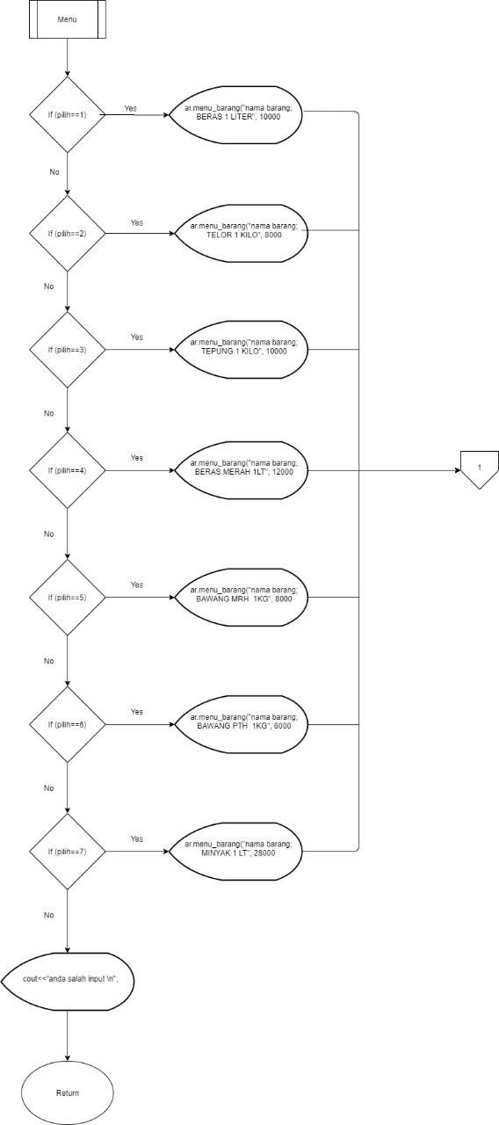

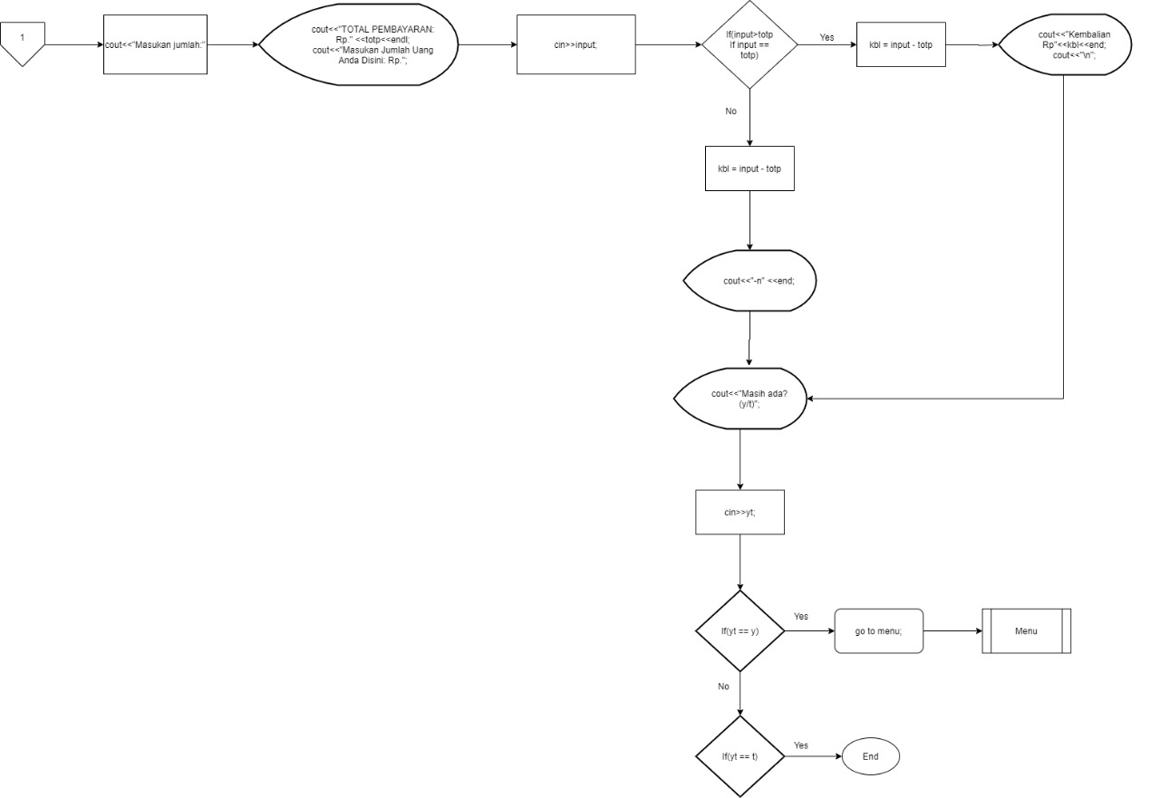

**C++ CODE INPUT**

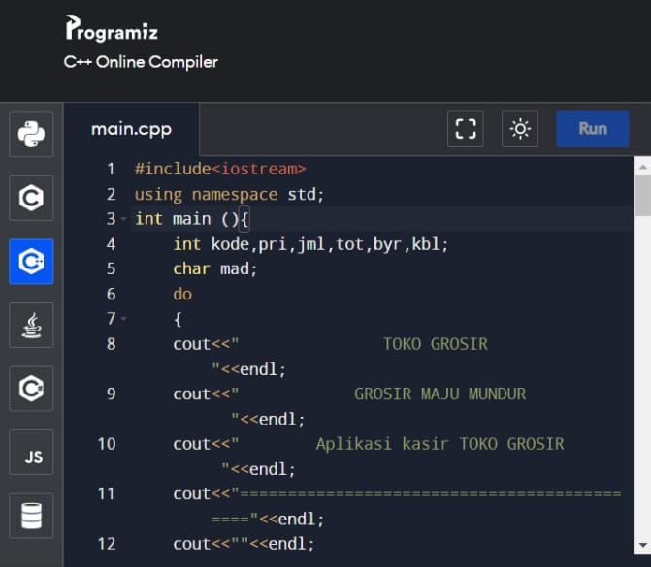

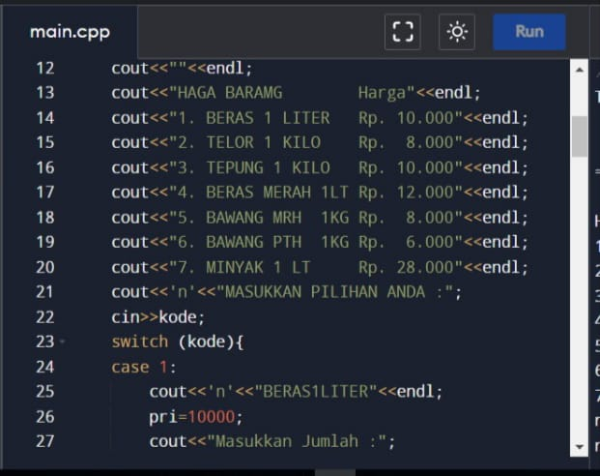

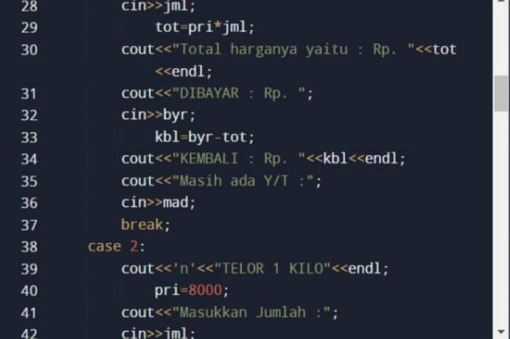

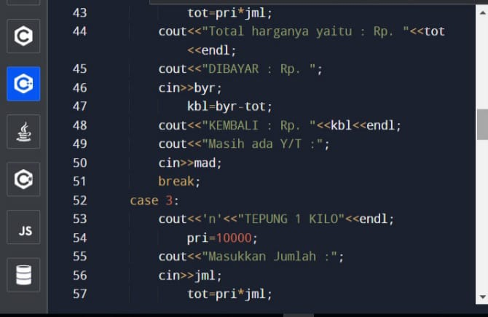

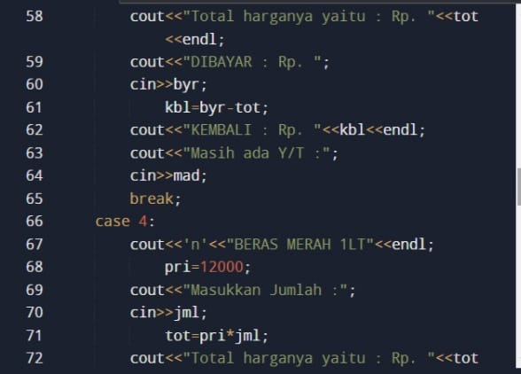

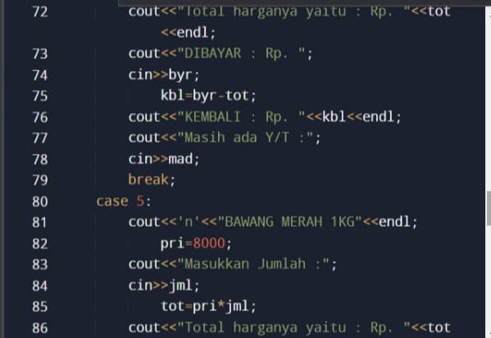

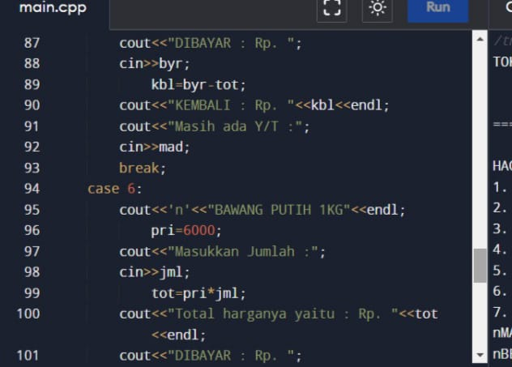

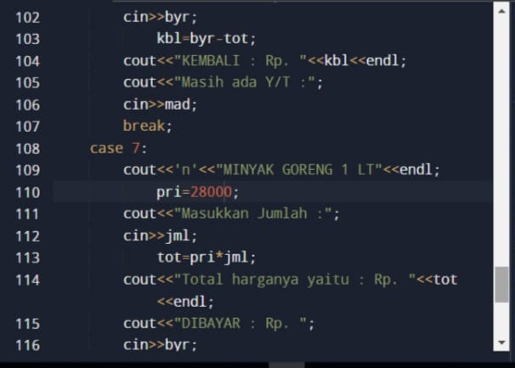

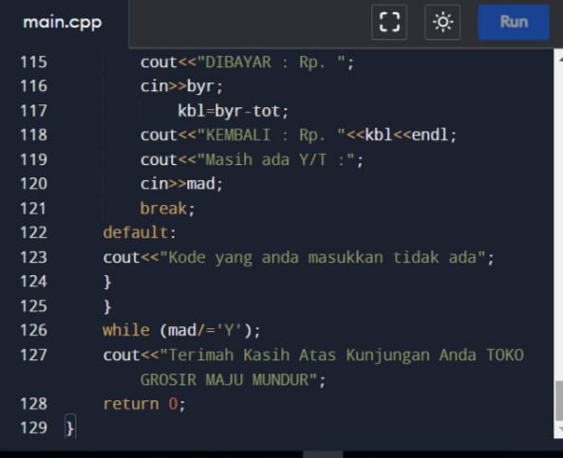

**C++ CODE OUTPUT**

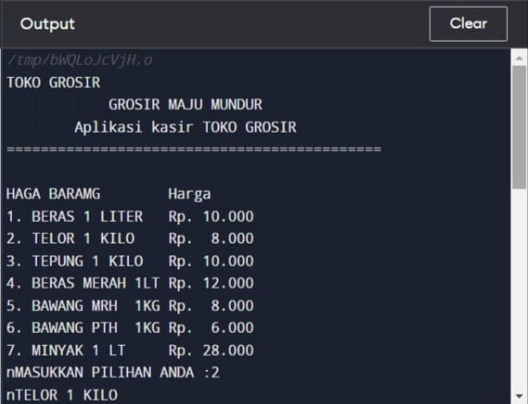

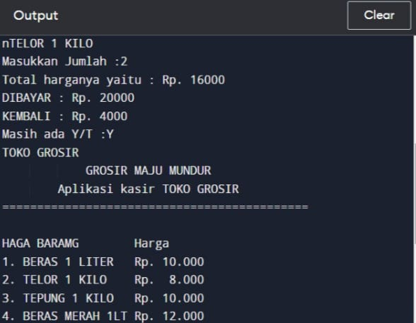

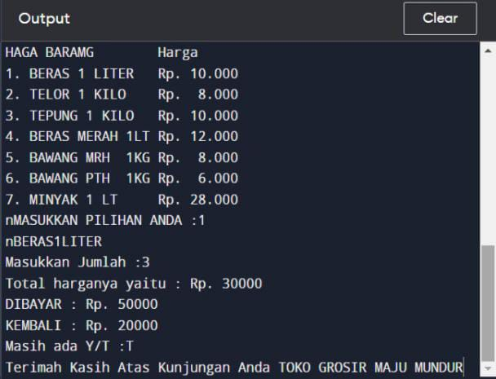

**Hardware :**

Laptop, Lenovo ideapad AMDA A4, 4 GB RAM, and 500 GB SSD

**Operating System :**

Microsoft Windows 10 Home

**Software :**

* Microsoft Word 2019
* Microsoft Power Point 2019
* Progammiz
* Draw.io

|  |  |  |
| --- | --- | --- |
| **PROJECT FILE DETAILS** | | |
| **No.** | **File Name** | **Remarks** |
| 1. | Project 1 Kel 1 Grosir cashir app.docx | File from MS Word that contain our research project. |
| 2. | Project 1 Kel 1 Grosir cashir app.docx | File from MS Power Point for Presentation. |

**CONFIGURATION**